Samuel Herbert Sparling
Private, 1st CMR Battalion, 3rd Canadian Division, #105990

Born: about 1884
Died from his wounds, September 18, 1916, age 31 years

Samuel Herbert’s Family

Samuel’s father was Joseph Sparling born 1839 in Trafalgar Twp, Halton, Ontario: deceased 1921 in Wallard, Swift Current, Saskatchewan. His mother, Ann Mercier Smeltzer, was born 1846 in Esquesing Twp, Halton Co, Ontario; deceased 1914 in Wallard, Swift Current, Saskatchewan. She was daughter of William and Ann (Thompson) Smeltzer. From his Attestation Papers, Samuel was born near Meaford, Ont, and when he enlisted he was farming in Avonhurst (presumed Saskatchewan). Samuel’s brothers were William Joseph Sparling and George Sparling. http://www.simonhoyt.com/sparling.html

Samuel Herbert’s Irish Palatine Ancestry

1x Grandparents: George Sparling, born 1768 in Killeheen, Limerick, Ireland m. (in 1813 in Parish Ch, Adare, Limerick, Ireland) Elizabeth Switzer, deceased 1839.
Grandparents: William Sparling, born 1804 in Ireland; deceased 1890 in Epping, Grey, Ontario, Canada m. Ann Marie Smeltzer, born 1813 in Kilcooly, Tipperary, Ireland;
http://www.simonhoyt.com/sparling.html

------------------------------------------------------------------------------------------------
https://en.wikipedia.org/wiki/1st_Battalion,_Canadian_Mounted_Rifles,_CEF
The 1st Battalion, Canadian Mounted Rifles, CEF, was an infantry unit of the Canadian Expeditionary Force in the First World War. Originally a mounted infantry unit named the 1st Regiment, Canadian Mounted Rifles, CEF, it was formed on November 7, 1914, in Brandon, Manitoba. Part of the 1st Brigade Canadian Mounted Rifles, the unit landed in France on September 22, 1915, where the conditions of the Western Front made its mounts more of a hindrance than a benefit. On January 1, 1916, both CMR brigades (six regiments) were dismounted, converted to infantry and reorganized as the 8th Infantry Brigade (four battalions). The 1st Regiment, CMR, became the 1st Battalion, CMR,^{[1]} and it absorbed half the personnel of the 3rd Regiment, CMR (the other half going to the 2nd Battalion, CMR).[

The 1st CMR, along with the 4th CMR, was manning the 3rd Division's front on June 2, 1916, when the Germans launched their assault at the outset of the Battle of Mount Sorrel. Its positions were overrun, and 557 of its 692 members (80%) were killed, wounded or captured.^{[3]}

The battalion was rebuilt over the summer, and it was one of the first Canadian Corps units to attack when the corps shifted to the Somme in late summer 1916.

Mouquet Farm, Sept 15 – 16, 1916

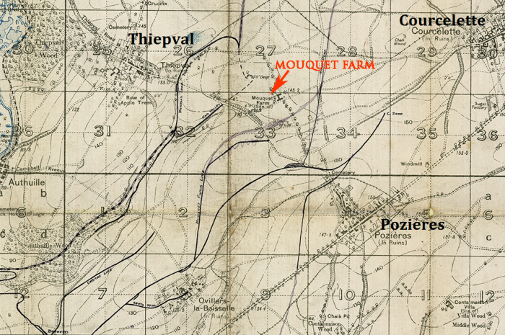
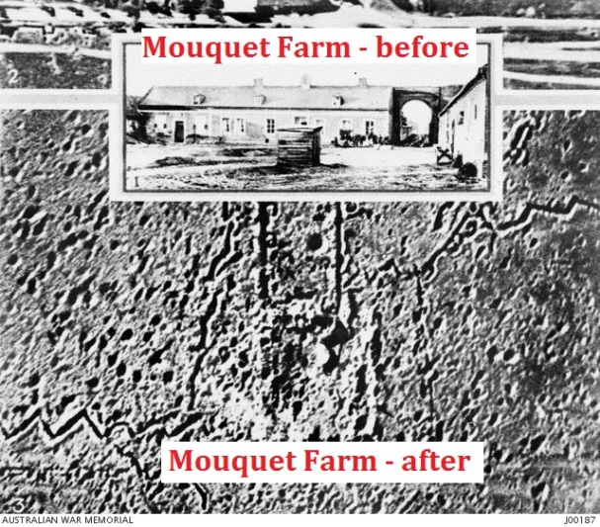

The Canadian Corps relieved the I Anzac Corps on 5 September.

On September 15, 1916, the 1st CMR was in the first wave attacking Mouquet Farm. The Canadians captured part of the farm on 16 September and were then repulsed by a counter-attack. By 25 September, further attacks had captured part of the farm on the surface but the Germans still held the cellars, dug-outs and tunnels beneath.
https://en.wikipedia.org/wiki/Battle_of_Mouquet_Farm

War Diary - 1st Battalion, Canadian Mounted Rifles – Sept 1916
http://data2.collectionscanada.ca/e/e045/e001124652.jpg

Sept 15, 1916 ”…at zero time 6:20 our No.1 party were in their shell holes out in front of the Trenches, and in rear of where our barrage should have been … our artillery, instead of playing on the enemy line, many of the shells fell amongst our own party inflicting many casualties…after the barrage lifted the enemy’s line was intact… as our men advanced they were met with a shower of cylindrical sticks as well as heavy machine gun fire… the heavy fire kept up until our front line suffered so many causalities that it was considered advisable to reinforce…
… theNo.2 party carried out a raid on Mouquet Farm… the enemy began shelling our front line vigorously…the hits were infrequent until the range was perfect and then there were many casualties … machine gun and rifle fire, especially sniping, was incessant throughout the day…
…causalities – 70 killed, 175 wounded, 11 missing…”

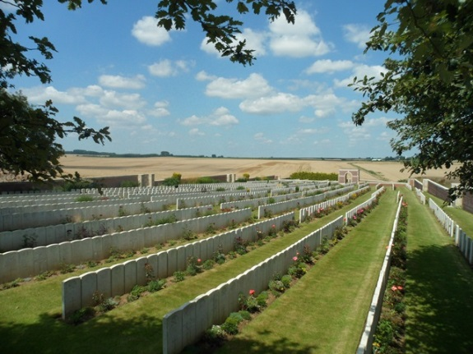
Samuel’s Resting Place

Samuel Herbert Sparling, 1st Canadian Mounted Rifles Battalion, died from his wounds 18 September 1916, age 31 years. It is presumed he suffered his wounds during the assaults on Mouquet Farm.

Samuel is interred Puchevillers British Cemetery, Somme, France

